21.51: For a uniformly charged disk, the electric field is given by Eq. (21.11):
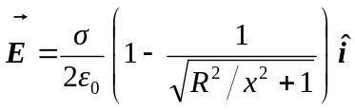
The -component of the electric field is shown below.

